1. We are required to develop a “Registration System”for ECNU. Following are problem statements:

A university ECNU wants to have a system for course and PhD thesis registration by which all students can register to current courses and PhD students can register their thesis proposal.

The list of current courses can be modified by authorized users only. Upon modification all involved persons have to be notified. Each thesis proposal submitted by a PhD student has to be approved by a professor who acts as the thesis supervisor.

Answer the following questions:

1. Find actors and give out each actor brief description;

Student: Students are from ECNU, who can register to current courses.

PhD student: A specialization of student, who can register theses proposal apart from the basic mothod of student.

Professor: The thesis supervisor of PhD students, who can approve thesis proposal of his or her students.

Administrator: The authorized person who can modify the list of current courses.

Course database: A database storing the list of current courses.

Thesis database: Adatavase storing the registered thesis.

1. Find appropriate Usecases
2. Modify current course-list
3. Release notification
4. Register course
5. Register thesis proposal
6. Approve thesis
7. Draw use case diagram.

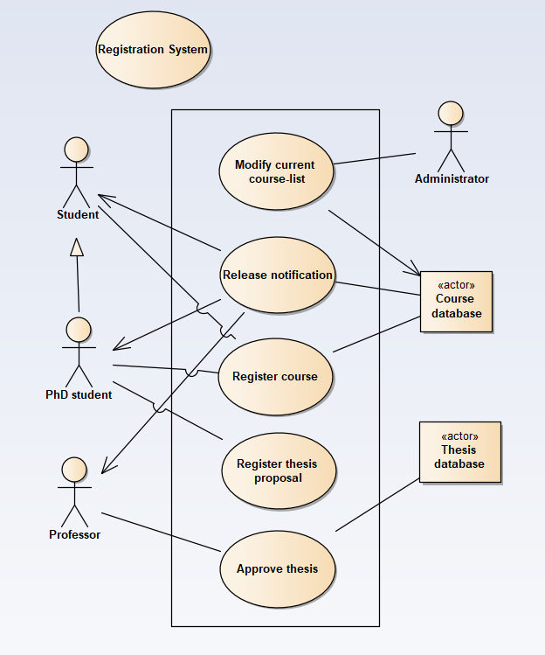

1. Give out detail description for one usecase (你自己任意选择一个用例).

* Release notification

Brief Description

The use case allows the Course database to release the notification of the modification of the list of the current courses.

Flow of Events

* Basic Flow
  + The use case starts when the Administrator finish modifying the list of current courses.
  + Once the Administrator submit the modify, the Course database find relevant modification information and identify the people involved.
  + Course database will release notification to people involved in the modification.
  + Involved people receive the notification
* Alternative Flows

If the student wish to register the newly changed course, he or she can register it.

Special Requirements

None

Pre-Conditions

The Administrator must modify the list of current courses before this use case begins.

Post-Conditions

The system state is unchanged by this use case.

Extension Points

None

2. An airline reservation system has the following requirements:

Customers shall be able to see which destinations are available.

Customers shall be able to choose a flight from a selection available travelling from their current location to their destination.

Customers shall be able to see which seats on a chosen flight are available.

Customers shall be able to book chosen seats on a chosen flight if they are available.

The system shall resolve concurrent booking requests from different customers for the same seats on the same flight by accepting the first booking and rejecting later bookings.

The system shall notify the customer of success or failure and show booking details.

Produce an analysis of this system and answer the following questions:

1. Give out Actor Lists and brief description for each one

Customer: Users who wish to see the available destinations and their information and choose flights including the available seats and receive success or failure notification from the system.

Supervisory system: A system from the airline company to receive customer’s orders and resolve concurrent booking requests from different customers for the same seats on the same flight by accepting the first booking and rejecting later bookings. After customer’s booking, the system will notify the customer of success or failure and show booking details.

Database: Record flight information, including the seats.

1. Find appropriate Usecases, and draw use case diagrams for the above requirements (do not produce a separate diagram for each requirement).

Usecases:

1. See available destinations
2. Choose flight
3. See available seats
4. Choose seats
5. Book ticket
6. Pass or Reject booking
7. Inform customer

Use case diagram:

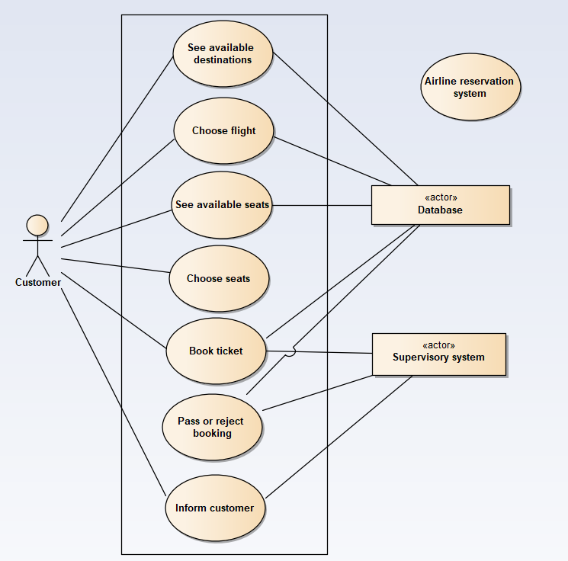

1. Give out detail description for one usecase.

* Pass or reject booking

Brief Description

The use case allows the Supervisory system from the airline company to judge whether pass the booking order from customers or not. First booking order of a seat of the flight can be passed while others will be rejected.

Flow of Events

* Basic Flow
* This use case starts when the customer submit the booking order.
* Supervisory system distinguish the first order of a seat of the flight.
* Modify the database that set the seat of the flight not empty and add the order.
* At the end of this case, start the next case named “Inform customer”
* Alternative Flow
* If the booking is the first order, pass the booking.
* Otherwise, reject the booking.

Special Requirements

None

Pre-Conditions

Customer submit the booking order with the information of airline and seat chosen.

Post-Conditions

The database state is changed by this use case.

After this use case, the next use case called “Inform customer” will start.

Extension Points

None